**Yeojin Kim**

Current Address: 2673-32, Yongdam-il-ding,Jejusi, Jeju, Korea

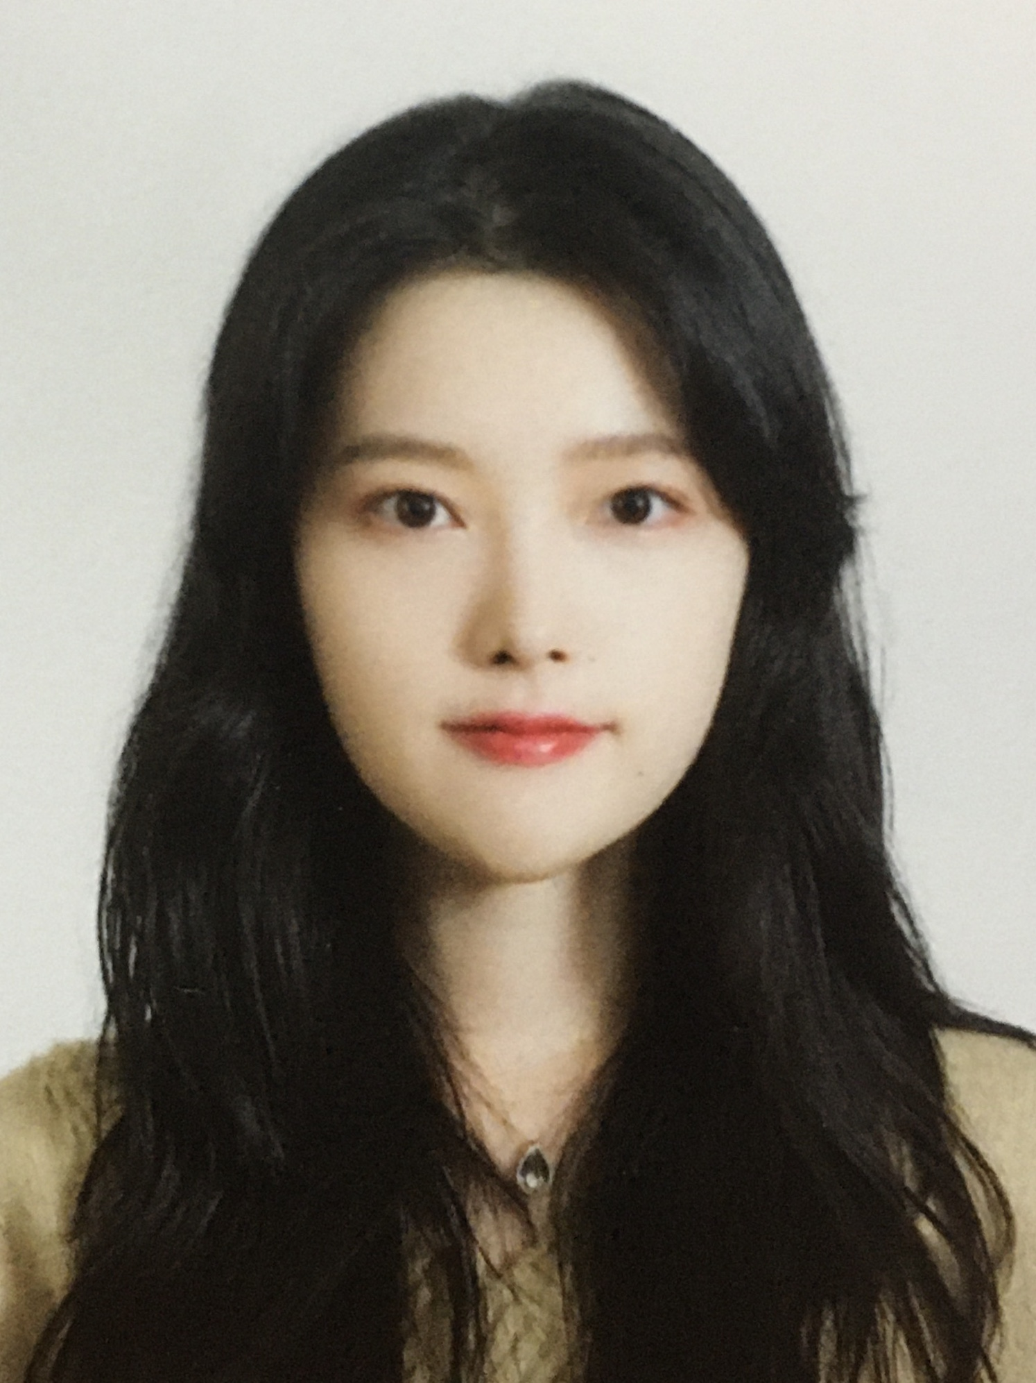

Telephone Number (Home): +82-10-6655-0337 Telephone Number (Cell): +82-10-4477-0081

E-mail: 95.jin.k@gmail.com Skype ID: 95.jin.k@gmail.com

Date of Birth: 10/25/1995 Place of Birth: Jeju, Korea

Country of Citizenship: Korea

Field of Training Desired: Video editi,Graphic design

Length of Program Desired: 12 months

Date Available to Start Training: ASAP

**Profile**

I am excellent in various design programs especially in Photoshop, Illustrator, and Premiere

I managed to work effectively to complete my works with those tools. Also, I have acquired strong leadership, good communication, and interpersonal skills through various activities. US internship will be a great opportunity to deepen my experts and perspective in design industry, so I would like to participate in this program.

**Education**

Bachelor’s Degree in Multimedia Design

Jeju National University, Jeju Republic of Korea

March 2015 – February 2020

Relevant Courses: Foundation design, Basic computer graphic design techniques, Design theory, Solid design, Typography design, Art Appreciation, e-Content UX / UI Design, Industrial Design UX Idea Method, Brand & Package Design, Digital drawing, Public Culture Environment Design, Visual promotion content design, Visual media identity design, Motion graphics design, Visual IMC Capstone Design, Industrial IMC Capstone Design, 3D CG Animation Design

Naiagara College

January 2019 - February 2019

100 Niagara College Blvd, Welland, ON L3C 7L3, Canada

English Language Course: : Academic Writing, Reading, Grammar, Listening and Speaking

**Work Experience**

Office Assistant

A.O.D map company,Jeju,Republic of korea [http://aodmap.com/]

February 2017 – July 2017

Responsibilities/Achievements :

● Job training on the field

● Learned Illustrator ability and field experience ability

● Cartography and Field Experience

Office Assistant

THE EDIT, Seoul,Republic of korea [http://the-edit.co.kr]

July 2019 - January 2020

Responsibilities/Achievements :

● Job training on the field, learned edit and project on-site.

● The company's 3rd anniversary party plan, poster design, graphics, stickers, videos, etc.

● Web design, banner design (YouTube, Facebook, homepage), logo design for Sicily projects

● Editing 'vllo Review' on YouTube channel ‘the edit’

● Editing ‘Fresco Review’ on YouTube channel ‘the edit’

● Designed thumbnails for YouTube 'the edit' channel and 'the edit life' channel

● Attend an invited party or promotion as an influencer

**Technical Knowledge**

* Photoshop 9/10
* Rhino 7/10
* Maya 6/10
* Illustrator 9/10
* Premier 9/10
* Ligtroom 7/10
* AfterEffect 8/10

**Other Skills & Certificates**

Languages: Korean – Native, English – Intermediate

Other computer skills: MS Office(Word – Advanced, Excel – Advanced, Powerpoint – Advanced , Access - Advanced)

Certificates/Awards:

* Driver License - 2008
* Engineer Information Processing – 2015
* Oracle Database 11g Administrator Certified Professional(OCP) – 2016
* Patent Registering(Forward Head Posture Prevention System) – 2014(ongoing)

**Activities**

Workcamp, Iceland

June 2013 – July 2013

Volunteer worker

* Assisted in various activities and helped care for Icelanders
* Volunteer for environmental improvement and assisted greenhouse cultivation

School band Logout, Korea

March 2008 – June 2015

Chairman(December 2008 – December 2009)

* Mediator between seniors and juniors
* Managed all the process of the concert (Planning, Casting, Preparing for the performances, process of the event)

Hanium(IT mentoring), Korea

January 2014 – December 2015

Mentee

* Learned about IT trends, planning of new business development
* Forward Head Posture Prevention System Development